PROJECT DOCUMENTATION

Explainable AI Framework for Employee Attrition

Prediction
Group 1
P. Sree Bhuvaneswari - 2420030519
B. Guru prasad- 2420090089
M. Witty - 2420030759

Project Title
Explainable AI Framework for Employee Attrition Prediction is a significant challenge for organizations, as the departure of skilled employees can increase recruitment costs, reduce productivity, and affect organizational growth. The proposed Explainable AI Framework uses machine learning techniques to predict whether an employee is likely to leave the organization. The system analyzes factors such as age, job role, monthly income, job satisfaction, work-life balance, overtime, years at the company, distance from home, and promotion history.The framework also provides clear explanations for each prediction using Explainable AI techniques such as SHAP or LIME. These explanations help HR professionals understand the factors influencing employee attrition and support better decision-making. For example, the system can identify whether factors such as excessive overtime, low job satisfaction, limited career growth, or salary are contributing to an employee's decision to leave. This framework helps organizations take preventive actions and improve employee retention.

2. Problem Statement
•Organizations often have employee data, but identifying employees who may leave is difficult.
Existing challenges:
•Employee attrition is influenced by multiple factors.
•Traditional ML models may behave like black boxes.
•A prediction alone does not explain the reason.
•HR needs understandable information before taking action.
•Employee data can be imbalanced, making attrition prediction difficult.

3. Objectives
•To develop a Machine Learning model for predicting employee attrition.
•To identify the important employee and job-related factors influencing attrition.
•To apply Explainable AI techniques such as SHAP and LIME to explain model predictions.
•To provide both overall feature importance and individual employee explanations.
•To evaluate the model using Accuracy, Precision, Recall, F1-score and ROC-AUC.
•To present the results in a simple form that can support HR decision-making.

4. Proposed Model / Framework
IBM HR Dataset
↓
Data Preprocessing
↓
Feature Selection
↓
Machine Learning Model
↓
Attrition Prediction
↓
Risk Probability
↓
SHAP + LIME
↓
Employee Risk Profile
↓
HR Decision Support

5. Literature Survey
The following survey combines the papers already identified in the project presentation with additional closely related research on neural question generation, long-context question generation, relevance, answer-awareness, reinforcement learning, and text-to-text Transformer models. The limitations column is written specifically from the perspective of the proposed technical-document FAQ system; therefore, it identifies the gap that remains when the research is applied to multi-format technical documents and FAQ generation.
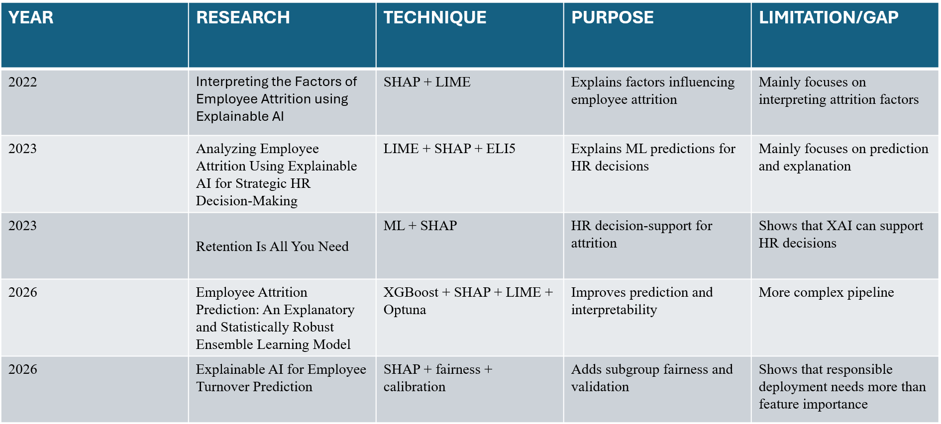

6. Research Gap Identification
Existing research already provides:
Attrition prediction
SHAP-based explanations
LIME-based individual explanations
Ensemble models
Risk scoring
Fairness analysis
HR decision support

7. Innovation
Employee Attrition Risk Profile
Instead of giving only:
Prediction: Employee may leave
our system produces an understandable profile:
Employee Risk Profile
Attrition Risk: High
Probability: 82%
Main factors:
High OverTime
Low Job Satisfaction
Low Work-Life Balance

Why this is useful:
HR can see the prediction + probability + reasons in one place, instead of interpreting separate ML outputs.

8. Creativity
- The project combines:
- Machine Learning
- Explainable AI
- Employee risk scoring
- Individual-level explanations
- Simple HR visualization

9. Novelty
Our proposed framework integrates:
Prediction
↓
Risk Score
↓
Why? — SHAP/LIME
↓
Employee Risk Profile
↓
HR Decision Support

10. Feasibility Analysis
Technical Feasibility
- Python
- Pandas
- Scikit-learn
- XGBoost / Random Forest
- SHAP
- LIME
- Streamlit
Economic Feasibility
- Public dataset
- Open-source libraries
- No expensive software required
- Can be developed on a normal laptop
Operational Feasibility
- Simple HR dashboard
- Easy-to-understand output
- Can support HR analysis
- Can later be adapted to organization-specific data

11. Project Plan — Complete Workflow of Execution
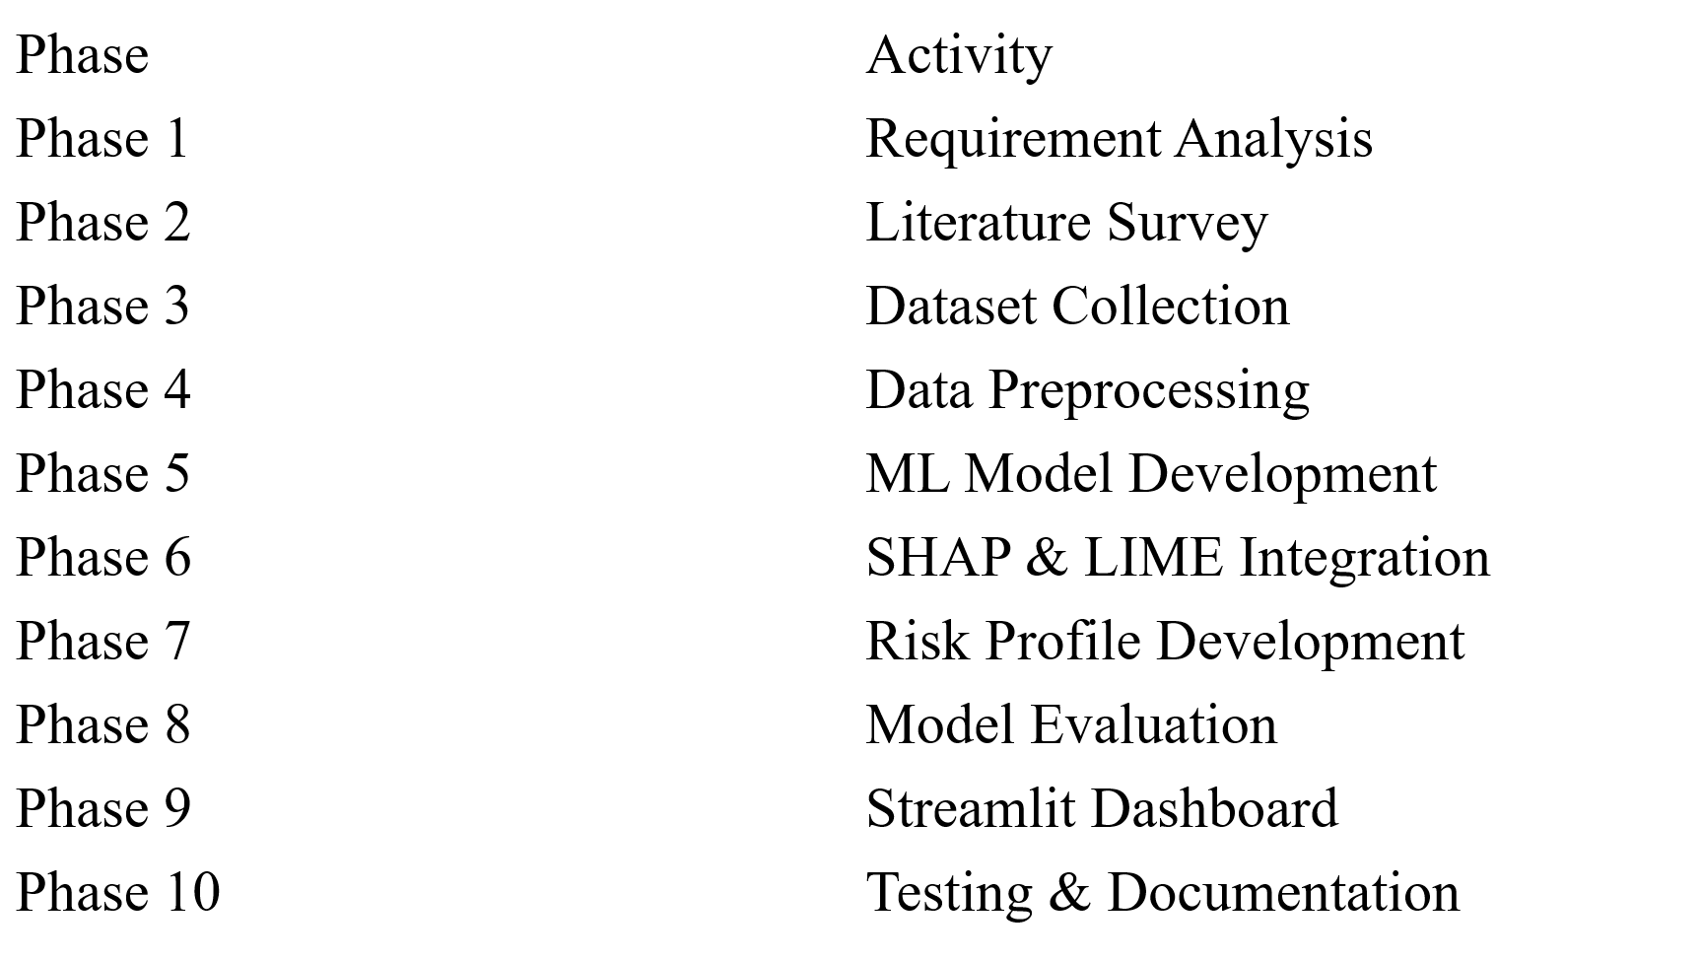

12. Datasets and Project Data Sources
No. | Dataset | Description | URL
1 | IBM HR Analytics Employee Attrition | Employee details and attrition prediction | https://www.kaggle.com/datasets/pavansubhasht/ibm-hr-analytics-attrition-dataset
2 | IBM Employee Attrition CSV | CSV dataset commonly used for machine learning projects | https://raw.githubusercontent.com/IBM/employee-attrition-aif360/master/data/emp_attrition/WA_Fn-UseC_-HR-Employee-Attrition.csv
3 | HR Analytics Dataset | HR-related employee information for analytics | https://www.kaggle.com/search?q=HR+Analytics+Employee+Attrition+Dataset
4 | Employee Attrition Dataset | Multiple employee attrition datasets | https://www.kaggle.com/search?q=employee+attrition+dataset
5 | HR Employee Dataset | Employee records for HR analytics and prediction | https://www.kaggle.com/search?q=HR+employee+dataset
6 | Employee Turnover Dataset | Data related to employee turnover and retention | https://www.kaggle.com/search?q=employee+turnover+dataset
7 | Employee Churn Dataset | Dataset for predicting employee churn | https://www.kaggle.com/search?q=employee+churn+dataset
8 | HR Employee Attrition | Additional datasets for attrition classification | https://archive.ics.uci.edu/search?search=employee+attrition
9 | Employee Attrition Data | Public repositories containing employee attrition data | https://github.com/search?q=employee+attrition+dataset&type=repositories
10 | HR Analytics and Attrition | Various datasets for HR prediction projects | https://datasetsearch.research.google.com/search?query=employee%20attrition%20dataset

13. Expected Outcome
Prediction
“Is this employee likely to leave?”
Risk
“How high is the predicted risk?”
Explanation
“Which factors influenced the prediction?”
Decision Support
“What information should HR consider?”
Final idea:
Our goal is not only to predict employee attrition, but to make the prediction understandable and useful for HR.

14. Project Timeline
Period | Work Package | Major Deliverables
Weeks 1–2 | Research | Literature survey, problem identification, requirement analysis, dataset and tool selection
Weeks 3–4 | System Design | Framework architecture, machine learning workflow design, feature selection and model selection
Weeks 5–6 | Data Processing | Dataset collection, data cleaning, handling missing values, encoding categorical data and feature engineering
Weeks 7–8 | Machine Learning Model Development | Model training using Logistic Regression, Random Forest and other suitable algorithms; initial experiments
Weeks 9–10 | Explainable AI Integration | SHAP/LIME integration, feature importance analysis and generation of understandable prediction explanations
Weeks 11–12 | Testing & Documentation | Model evaluation, accuracy/precision/recall/F1-score analysis, framework testing, final report and presentation

15. References and Research Resources
• Jia, H. (2026). Explainable AI for employee turnover prediction: a SHAP-based intelligent analytics approach. Scientific Reports.
Read the paper
• Al-Ali et al. (2026). Integrating machine learning and explainable AI for employee attrition prediction in HR analytics. Scientific Reports. This research combines machine learning models with SHAP explanations for transparent HR analytics.
Read the paper
• Al Akasheh et al. (2024). A decade of research on machine learning techniques for predicting employee turnover: A systematic literature review. Expert Systems with Applications.
Read the paper
• Ribeiro, Singh, & Guestrin (2016). Why Should I Trust You?: Explaining the Predictions of Any Classifier. This is a foundational research paper for the LIME explainability technique.
Read the LIME paper
• Employee Attrition Prediction using Machine Learning: A Data-Driven Approach for Workforce Analytics (2025). IEEE.

16. Source Alignment Note
The proposed Explainable AI Framework for Employee Attrition Prediction is developed based on information gathered from relevant research papers, publicly available employee attrition datasets, and official machine learning and Explainable AI resources. The selected datasets, methodologies, machine learning models, and explainability techniques are aligned with the objectives of predicting employee attrition and identifying the key factors influencing employee turnover. Research resources such as Scikit-learn, SHAP, LIME, and the IBM HR Analytics Employee Attrition Dataset support the implementation and evaluation of the proposed framework. All sources are appropriately referenced to ensure consistency, reliability, and academic relevance throughout the project.

